Excel Homework

1. What are three conclusions we can make about Kickstarter campaigns given the provided data?

* 53% of the total campaigns were successful and 37% failed. Also, the four most significant categories were “Theater”, “Music”, “Technology” and “Film & Video” with 34%, 17%, 15% and 13% of the total campaigns respectively. Additional, 74% of the total campaigns were in US and 15% in GB, which means that almost 90% of the total campaign were in those two countries.
* The subcategory “Play” was the most significant category of the total campaigns in US and GB under category “Theater”.

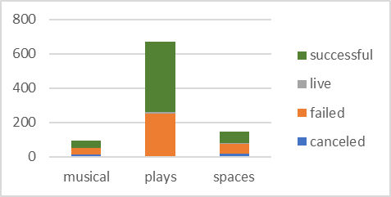 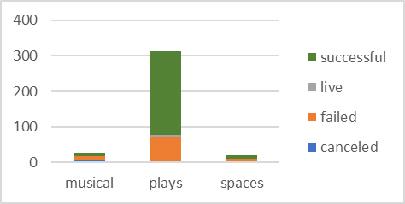

GB

US

Also, subcategory “Rock” under Category “Music” for campaigns in US was the most important and successful campaign.

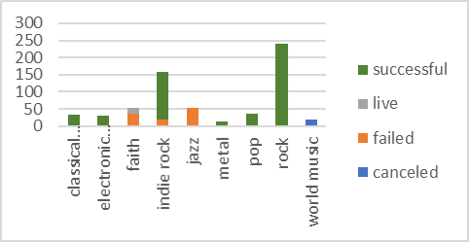

US

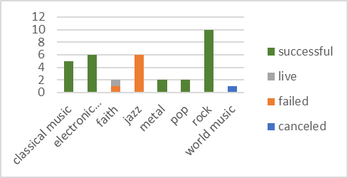

GB

* Under category “Theater” during the last 3 years (without counting 2017 because is no complete and can get down my average) we can see tend that those campaigns launched in may are likely successful than those launched at the end of the year.

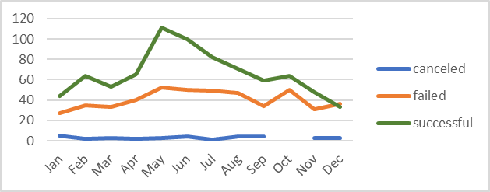

Under category “Music” during the last 5 years (without counting 2017 because is no complete and can get down my average) we can see tend that those campaigns launched at the beginning of the year are likely successful than those launched at the end of the year.

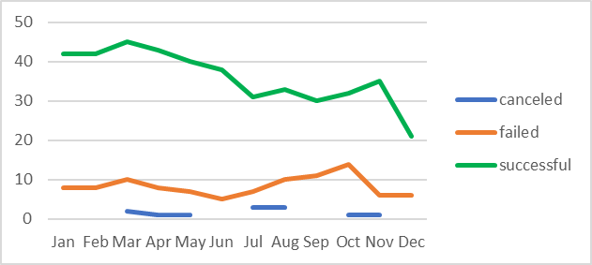

1. What are some of the limitations of this dataset?

Some limitations I checked from this database was that there isn’t campaigns launched at some months of some years. This makes the analysis of trends tend to going down in order to see the tend of successful or failed.

1. What are some other possible tables/graphs that we could create?

* Check by Country to see which countries are the ones with more campaigns and check by those the categories and Subcategories.
* Check Percentages of the total of each variable to easily compere total campaigns by categories under each variable.
* I think it would be useful to make Pie charts in order to get number of campaign distribution by categories and countries.
* It would useful to see by category and groups of percentages the “Percent Funded” in order to get an idea of which campaigns were too low under or too high over the goal.